# **SQL Assignment 3**

USE DATABASE SQL;

USE SCHEMA PUBLIC;

CREATE TABLE sales (

order_id INT PRIMARY KEY,

customer_id INT,

product_id INT,

product_name VARCHAR(50),

quantity INT,

unit_price DECIMAL(10, 2),

order_date DATE

);

INSERT INTO sales (order_id, customer_id, product_id, product_name, quantity, unit_price, order_date)

VALUES

(1, 101, 1, 'Widget A', 5, 10.00, '2023-01-15'),

(2, 102, 2, 'Widget B', 2, 12.50, '2023-01-16'),

(3, 103, 1, 'Widget A', 3, 10.00, '2023-01-16'),

(4, 104, 3, 'Widget C', 1, 15.75, '2023-01-17'),

(5, 105, 2, 'Widget B', 4, 12.50, '2023-01-17'),

(6, 106, 1, 'Widget A', 2, 10.00, '2023-01-18'),

(7, 107, 4, 'Widget D', 3, 20.00, '2023-01-18'),

(8, 108, 2, 'Widget B', 5, 12.50, '2023-01-19'),

(9, 109, 1, 'Widget A', 1, 10.00, '2023-01-19'),

(10, 101, 3, 'Widget C', 2, 15.75, '2023-01-20');

SELECT * FROM SALES;

--1. Retrieve the total sales quantity and revenue for each product.

SELECT PRODUCT_NAME, SUM(QUANTITY) AS TOTAL_SALES_QUANTITY, SUM(QUANTITY*UNIT_PRICE) AS TOTAL_REVENUE

FROM SALES

GROUP BY PRODUCT_NAME;

--2. Find the total revenue for each customer

SELECT CUSTOMER_ID, SUM(QUANTITY*UNIT_PRICE) AS TOTAL_REVENUE

FROM SALES

GROUP BY CUSTOMER_ID;

--3. Get the products with more than 10 units sold in a single order.

SELECT * FROM SALES

WHERE QUANTITY>10;

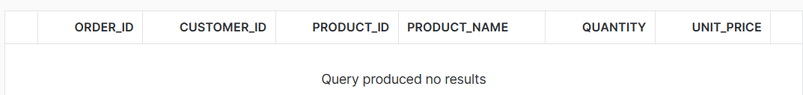

--4. List the customers who have placed orders on at least three different dates.

SELECT CUSTOMER_ID,COUNT(DISTINCT(ORDER_DATE))

FROM SALES

GROUP BY CUSTOMER_ID

HAVING COUNT(ORDER_DATE)>=3;



--5. Calculate the average unit price of products

SELECT PRODUCT_ID, PRODUCT_NAME, ROUND(AVG(UNIT_PRICE),2)

FROM SALES

GROUP BY PRODUCT_ID, PRODUCT_NAME

--6. Find the products with an average unit price greater than $12.00

SELECT PRODUCT_ID, PRODUCT_NAME, ROUND(AVG(UNIT_PRICE),2) AS AVG_UNIT_PRICE

FROM SALES

GROUP BY PRODUCT_ID, PRODUCT_NAME

HAVING ROUND(AVG(UNIT_PRICE),2)>12;

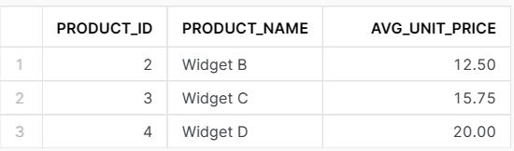

--7. Retrieve the customers who have spent more than $100.00 in total.

SELECT CUSTOMER_ID, SUM(QUANTITY*UNIT_PRICE) AS TOTAL_REVENUE

FROM SALES

GROUP BY 1

HAVING TOTAL_REVENUE > 100;



--8. List the customers who have purchased 'Widget B' and 'Widget A' in the same order.

SELECT CUSTOMER_ID, PRODUCT_NAME

FROM SALES

WHERE PRODUCT_NAME= 'Widget B' AND PRODUCT_NAME= 'Widget A';

